Use DudasBI with Apache Kylin

Date: Dicember 2016
Author: Ramón Portolés, Alberto Linkedin

Intro
We can use Quick Start with Sample Cube of Kylin Project to make an example of integration with Dundas BI

Kylin Pre-requisites
First, you need Build Kylin Cube: Quick Start with Sample Cube: With firth step of link, you can check the result cube executing:
select part_dt, sum(price) as total_selled, count(distinct seller_id) as sellers from kylin_sales group by part_dt order by part_dt
Query results:
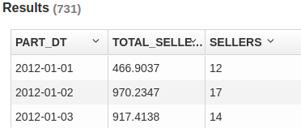

Used Software
- Kylin: 1.6.0
- Kylin ODBC 1.6
- Dundas 3.0.2.100

Create Connection
- Install Kylin ODBC
- Add DSN System in Windows (this program dont work with User DSN)
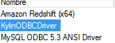
- And configure: User-name /Password: ADMIN / KYLIN
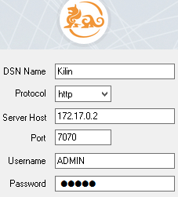
- Click Connect and Choose the project
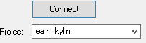
- Click on “Done”

Install Dundas Pre-requisites
Dundas Requeriments
Most of them are automatically installed on setup process , but Dundas requires an external SQL Server for intenal use:
“Microsoft SQL Server 2008 / 2008 R2 / 2012 / 2014 / 2016. We recommend using Microsoft SQL Server 2014 or higher
- Microsoft SQL Server Express Editions are supported but not recommended for production use due to limitations”
For PoC prouposes we will uses, SQL 2014 Express:
We dundas recomends Chrome or Firefox (IE explorer is not recomended)

We will process to standard install of Microsoft SQL Server:
With a minimum install:
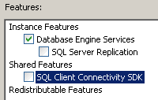

Create Dundas Proyect
To create a new isntance:
 >  > 
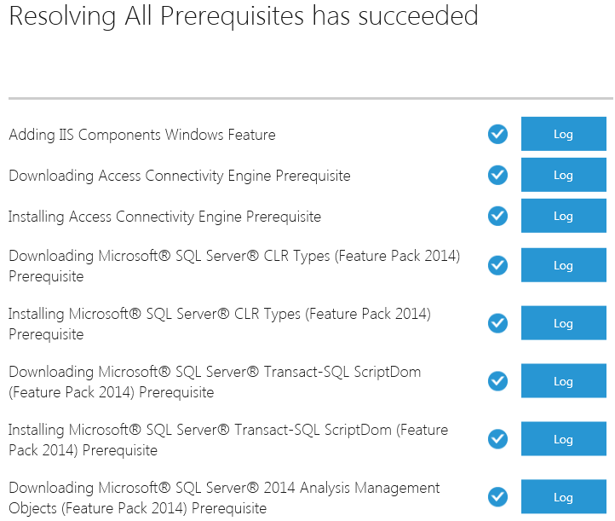

Put name of project
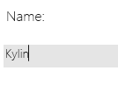

We will ned create a new database in our SQL Server
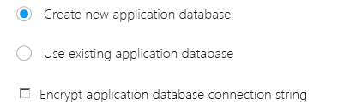

You must see your local SQL Server express
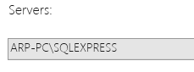

For the next option we will use default configurations
The result will be similar to:
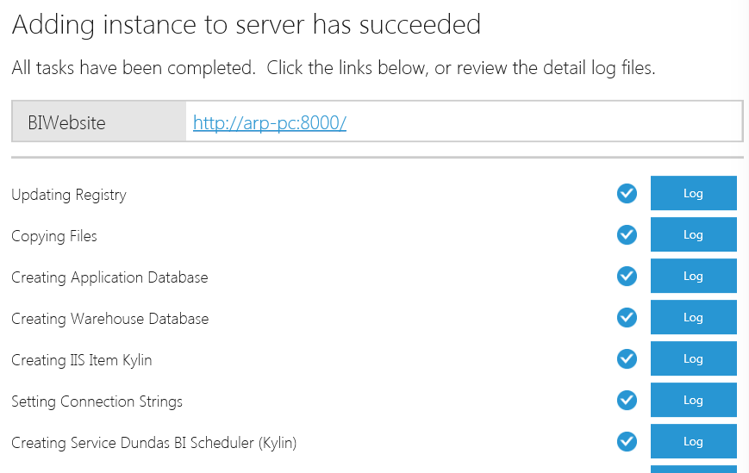

Connect to data proyect
Use your Web explorer, by default the login name is admin and password is the one that you specified during the installation procedure. (http://arp-pc:8000 ) and press 
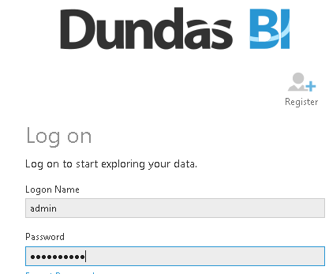

Connect Dundas with Kylin: Create Data Connector
Expand left menu
 > 

Put a name and type Data provider:
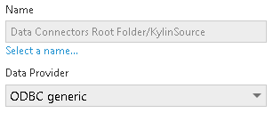

In authentication Method:
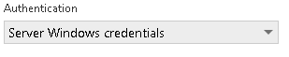

Very important, check System DSN: and doble clink on empty combobox
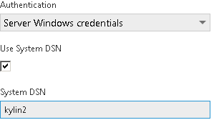

Don’t put any Password or Advaced:
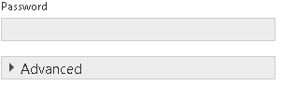

Load Table Metadata:
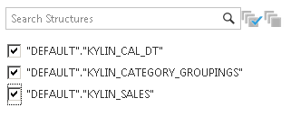
And Clik OK
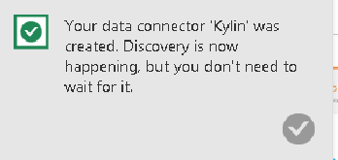

ERROR: Connection
Check:
- Your are using System ODBC on Windows, and works
- Dundas
  - Check uses System DNS (No user DNS)
  - Password is empty
  - Authentication is Server Windows Credential

Preview your data: Explore data
How / Where I can find my datasources
In you main Dashboard , “Explore Data”
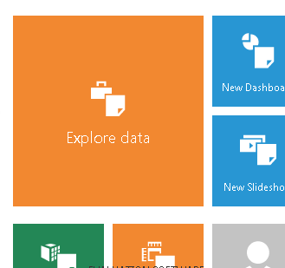
Rigth Menu, expand “Data Connections”
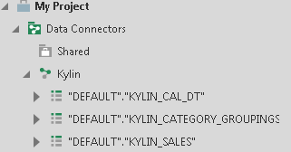

ERROR1:
In ODBC LOG
[INFO ][2016-12-06.19:05:30]SELECT * FROM "DEFAULT"."KYLIN_CAL_DT" WHERE 1 = 2
[INFO ][2016-12-06.19:05:30]Successfully done executing the query
[FATAL][2016-12-06.19:05:30]SQLColAttribute unknown attr, ColNum: 1, FldID: 1211

[FATAL][2016-12-06.19:05:30]In Shipping mode, Skip popping up window...
[FATAL][2016-12-06.19:05:30]SQLColAttribute unknown attr, ColNum: 2, FldID: 1211

I think the poupose of this query is only read list of columns,
this query don’t generate result on Kylin UI, but don’t give columns name

ERROR 2:
In ODBC LOG
ERROR][2016-12-06.19:30:27]The REST query request failed, the error message is: Error while executing SQL "SELECT T."USER_DEFINED_FIELD1" AS "TE0", T."SITE_ID" AS "TE1" FROM "DEFAULT"."KYLIN_CAL_DT" T GROUP BY T."USER_DEFINED_FIELD1", T."SITE_ID" ORDER BY T."USER_DEFINED_FIELD1", T."SITE_ID"": From line 1, column 106 to line 1, column 126: Column 'USER_DEFINED_FIELD1' not found in table 'T'

Nice
The KYLIN_CAL_DT is automatically detected>
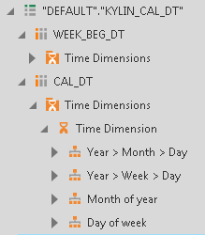

For any suggestions, feel free to contact me
Thanks, Alberto

